Arbuthnott Family Association

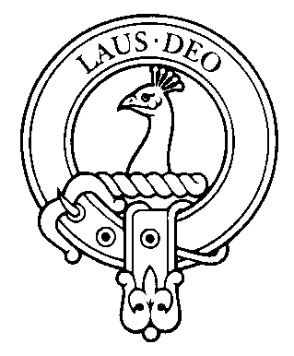

Newsletter 2009

Annual Gathering 2009 UK Branch,

This year the annual Gathering will return to London. We have been offered the use of the officer’s mess at the Inns of Court and City Yeomanry at Lincoln’s Inn. Officer’s Mess, Territorial Army Centre, 10 Stone Buildings, Lincoln’s Inn, London, WC2A 3TG

The Gathering will take place on Friday 16th October, at 6.30pm. The evening will start at 6.30pm, with drinks followed by a short AGM and then a buffet supper. The cost of the evening will be £25.00, including supper.

The main purpose of the evening is to meet family and friends and we would welcome and encourage partners and friends to join us.

68 (Inns of Court & City Yeomanry) Signal Squadron

The 2009 Gathering will be held in the Officer’s Mess at 10 Stone Buildings which is the Territorial Army Centre where 68 (Inns of Court & City Yeomanry) Signal Squadron are based.

Under various designations the Inns of Court & City Yeomanry can trace its history back to 1584 when the loyal Inns of Court formed associations to defend the realm against the threatened Spanish invasion. Gentlemen from the Inns also formed part of the Royalist Army in 1644. In 1745 the Regiment prepared for service against the Jacobite invasion and in 1780 it restored order during the Gordon Riots. During this time, William Pitt was a member of the Lincolns Inn Company.

Composed of members of the London legal community, the Regiment was nicknamed "The Devil's Own" by George III (who hated lawyers) at a Royal Review in Hyde Park in 1803. The nickname is still used today.

During the Second World War, the Inns of Court Regiment was reformed as an Armoured Car Regiment. It landed in France on the morning of D Day and served with distinction throughout the remainder of the NW Europe campaign.

In May 1961, the Inns of Court Regiment and the City of London Yeomanry amalgamated to form the Inns of Court and City Yeomanry and in 1969 became 68 (Inns of Court & City Yeomanry) Signal Squadron.

Over the years, in the defence of the country, Inns of Court & City Yeomanry soldiers have been armed with pikes, lances, swords, muskets, machine guns and now automatic rifles. They have ridden horses and bicycles and driven armoured cars, half tracks, tanks and land rovers.

In the past three years members of the squadron have served on Operations in Cyprus, the Balkans, Iraq and currently in Afghanistan.

Please can you complete the reply form to let me know if you are able to come to the gathering, so that I can confirm the arrangements with Julian Allen. My email address is c.arbuthnott@btopenworld.com and telephone number 0131 441 1815.

Family Gathering in July 2008 at Arbuthnott

The weekend started with an informal supper and reel party on Friday evening, in Montrose and the AGM. It was lovely to see 3 generations dancing together in a set and I know one Granny felt very proud to be asked to dance by her grandson. An array of kilts was on display, some enjoying their first outing which added to the colour of the evening.

Saturday gave an opportunity to travel to Paisley to see the Arbuthnott Missal and Psalter at Paisley Museum. The Museum had very kindly agreed to host a private viewing and David Roberts gave an explanation and history of these remarkable and very special manuscripts.

The Missal was the property of the Arbuthnott family until 1897 when it was purchased and presented to Paisley library and museum by Mr Archibald Coats of Paisley.
Written for use in the parish church of Arbuthnott, Kincardineshire in the late 15th century, the Arbuthnott Missal, Prayer Book and Psalter are three of Scotland's rare collection of beautiful and important medieval manuscripts.
The Missal is the only complete service book of its kind known to have survived the Reformation in Scotland. It provides a unique and irreplaceable insight into the forms of worship practised in Scottish churches not only at the time it was made, but for a period of around four hundred years before and after.
Apart from its unique significance in Scottish religion, the Missal is a rare and important example of Scottish medieval art and letters - a large, beautifully preserved volume of 246 pages, lavishly decorated with twenty three-quarter page border illuminations and illustrations, as well as finely painted miniature initials spaced throughout the text. A striking full-page miniature painting of St Ternan, patron saint of the church of Arbuthnott, is modelled on William Chevez, Archbishop of St Andrews, and can claim to be one of the earliest Scottish portraits.

The British Library has made digital copies of 30 pages from the Missal which can be viewed on line at http://www.bl.uk/ttp2/hiddentreasures.html

The Missal is not on general view at the museum and arrangements can be made to see the manuscripts if advance notice is given. Please let me know if you would like to arrange a visit to the museum, it is part of the family’s history that more of us should see.

Sunday was the real family day of the weekend, with many members of the family joining the Sunday service at Arbuthnott Kirk, lunch in the village hall and tours of Arbuthnott House and the farm in the afternoon. The group photograph taken after the service in the churchyard, in front of the family aisle, includes 107 people and gives a lovely record of a happy family gathering. Thank you to so many people for joining the event and for making it such a success.

The Family Aisle, at Arbuthnott Kirk

A number of people visited the aisle after the service and climbed the stairs to the priest’s room where the Missal was written in the 15th Centaury. While the aisle is an integral part of the church it belongs to the family and the cost for maintaining and repairing the aisle has to be funded by the family.

A major project to rebuild the roof on the aisle is nearing completion. It has been necessary to remove the carmyle slates, take the roof down to the wall head, replace the main bearers and batons, it some cases strengthening the bearers and replace the slates. All the work has used traditional methods including lime mortar and oak pegs to secure the slates. The result is very impressive and should keep the aisle wind and water tight for a good many years.

With this type of project the labour costs are huge and it has been impossible to estimate in advance as more horrors were uncovered. The final cost is likely to be around £30,000.

The Association would like to consider making a contribution to the repairs needed to the roof of the aisle. It is felt that this would be an appropriate use of the Association’s funds and the intension is to discuss this at the AGM in October. I would welcome any comments in advance of the AGM.

Family Website,

The family genealogical website has proved to be an excellent source of information for all Arbuthnot(t)s. Anyone who has not had a chance to view the site should register on line with www.kittybrewster.com Please contact either myself, c.arbuthnott@btopenworld.com or Sir William Arbuthnot, Family Genealogist, arbuthnot@kittybrewster.com if you have any items of family news which should be added to the website.

Merchandise

There is a stock of merchandise held for sale which includes woollen scarves, ties, bow ties, woollen shawls, silk head squares, travel rugs and photo frames. All made in tartan.

The tartan cloth is stored by the weaver at the mill and can be ordered from the secretary to be sent out direct.

All enquiries to c.arbuthnott@btopenworld.com or telephone number 0131 441 1815

Newsletter by E-mail.

The database of e-mail addresses is increasing and I am keen to capture as many as possible so that the newsletter can to distributed electronically to as many people as possible.

If you receive the newsletter by post and you would be happy to receive it by e-mail, please can you send me your e-mail address? Also, there maybe some people who receive the newsletter twice, once by post and secondly by e-mail, again please let me know and I will stop the postal copy.

Please can you send me your e-mail address to c.arbuthnott@btopenworld.com

Charles Arbuthnott 0131 441 1815 June 2009
7A Woodhall Bank, Edinburgh EH13 0HL

Reply Form.

Name
Address

Telephone number
e-mail address

Family Gathering Friday 16th October 2009.

Yes, I will be attending the Gathering on Friday 16th October in the Inns of Court and City Yeomanry Officer’s Mess.

Cost £25.00 per person
How many? ……..

Please return to Charles Arbuthnott
7A Woodhall Bank
Edinburgh
EH13 0HL

e-mail c.arbuthnott@btopenworld.com

telephone number 0131 441 1815

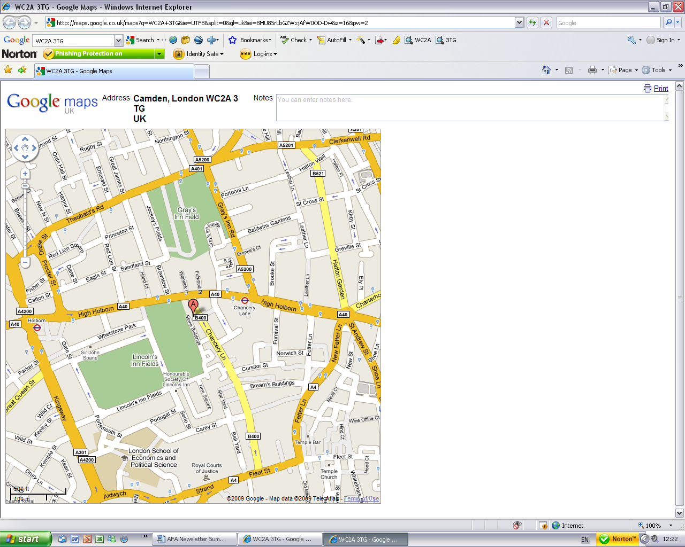
By car:
Lincoln’s Inn lies off A4200 Kingsway and A40 High Holborn. The entrance gate is through an arch on the east side of Lincoln’s Inn Fields. Please ask for 10 Stone Buildings and you will be directed to the car parking spaces outside.

By tube:
The nearest tube is Holborn on the Central line.
Walk round Lincoln's Inn Fields to the east side. Turn left through the arch into New Square. Turn left again after the War Memorial. Walk past the chapel on your right. You will come to a cul de sac lined with terraced houses on either side. 10 Stone Buildings is up on your right next to the Territorial Army sign.

10, Stone Buildings, Lincoln’s Inn, London, WC2A 3TG

